Test Case: tc001_SPX_Dev5_Crear_Solicitud_Articulo_Almacen
Step 1 - Enter username and password and click to button Enter : Credentials Entered
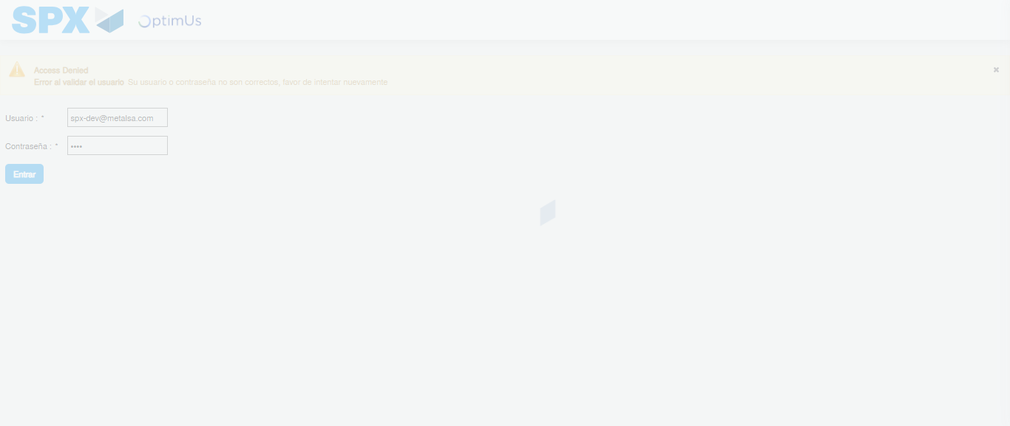Image file-name: QC_Testing-tc001_SPX_Dev5_Crear_Solicitud_Articulo_Almacen-1787933093086

Step 2 - Select to UEN and Access to Request for a New Inventory Item : UEN Correctly selected and Correct access
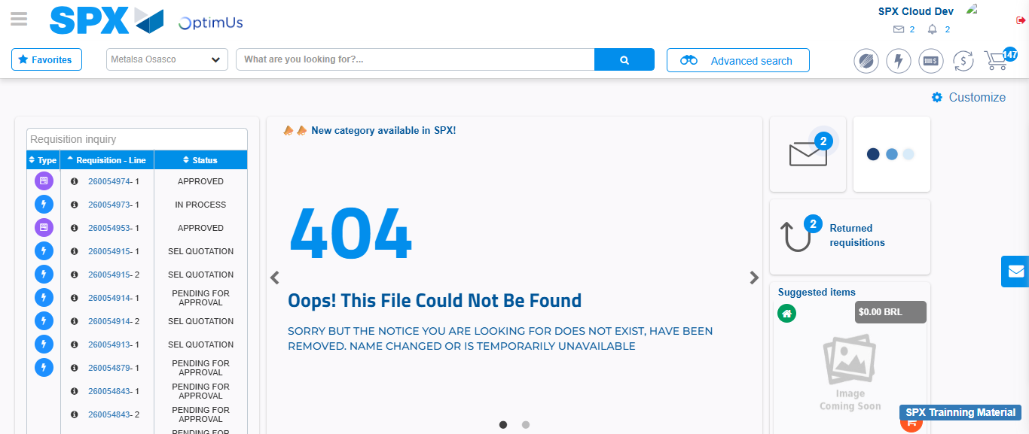Image file-name: QC_Testing-tc001_SPX_Dev5_Crear_Solicitud_Articulo_Almacen-1787933119359

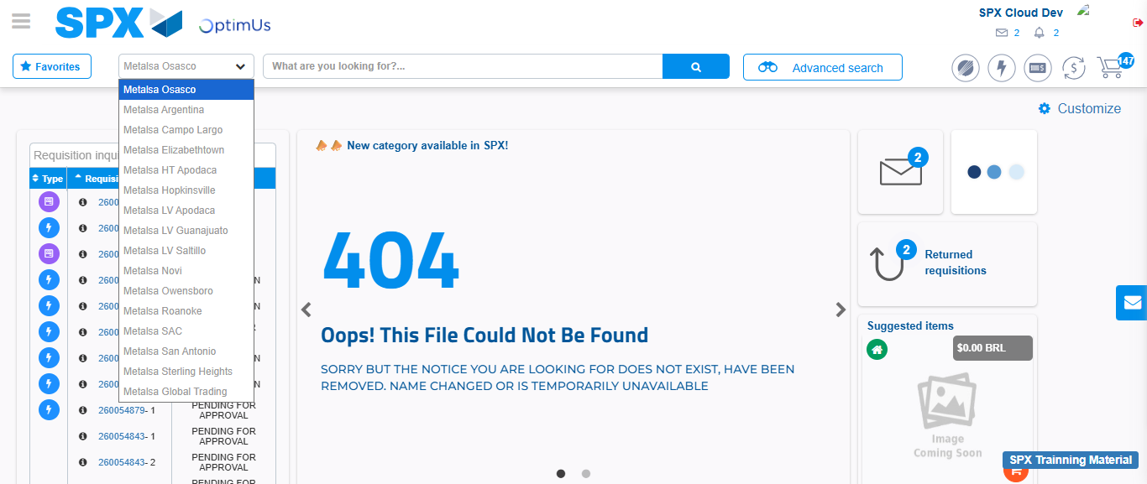Image file-name: QC_Testing-tc001_SPX_Dev5_Crear_Solicitud_Articulo_Almacen-1787933119909

Image file-name: QC_Testing-tc001_SPX_Dev5_Crear_Solicitud_Articulo_Almacen-1787933148725

Step 3 - Select options first section : Options seleted correctly
Image file-name: QC_Testing-tc001_SPX_Dev5_Crear_Solicitud_Articulo_Almacen-1787933149069

Image file-name: QC_Testing-tc001_SPX_Dev5_Crear_Solicitud_Articulo_Almacen-1787933149326

Step 4 - Select options at Screen: Options seleted correctly
Image file-name: QC_Testing-tc001_SPX_Dev5_Crear_Solicitud_Articulo_Almacen-1787933149069

Image file-name: QC_Testing-tc001_SPX_Dev5_Crear_Solicitud_Articulo_Almacen-1787933149326

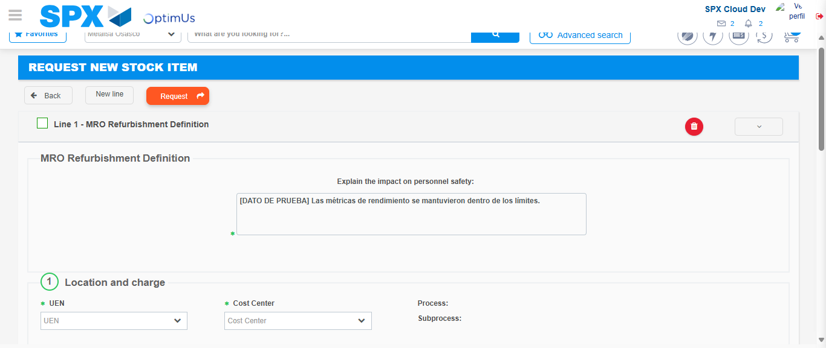Image file-name: QC_Testing-tc001_SPX_Dev5_Crear_Solicitud_Articulo_Almacen-1787933156966

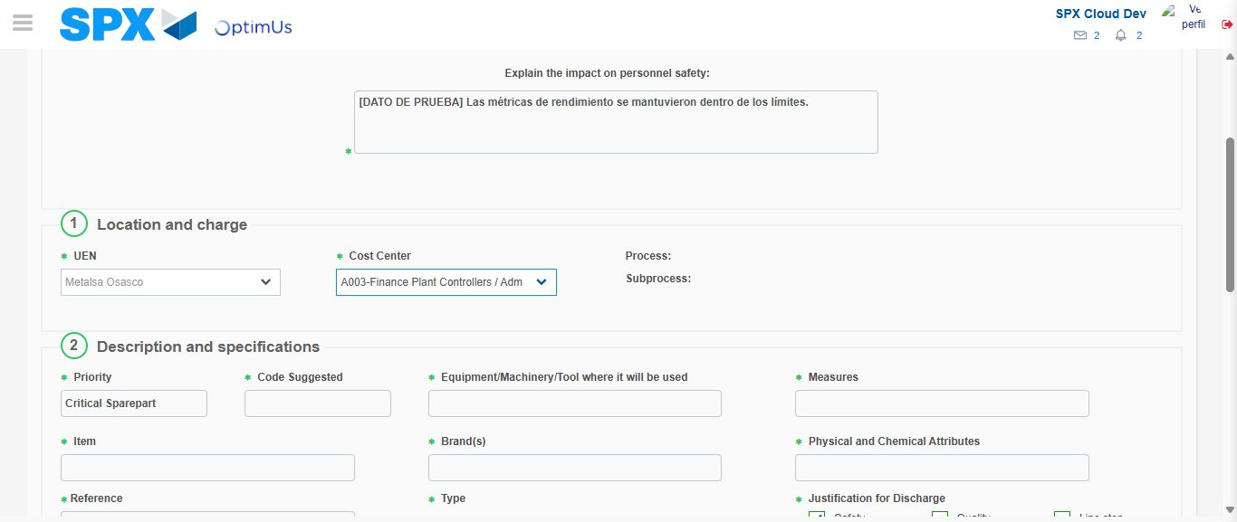Image file-name: QC_Testing-tc001_SPX_Dev5_Crear_Solicitud_Articulo_Almacen-1787933160184

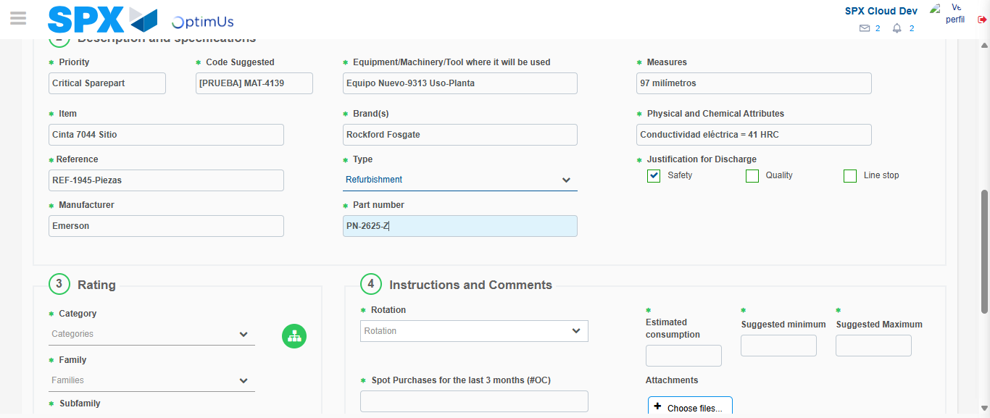Image file-name: QC_Testing-tc001_SPX_Dev5_Crear_Solicitud_Articulo_Almacen-1787933162103

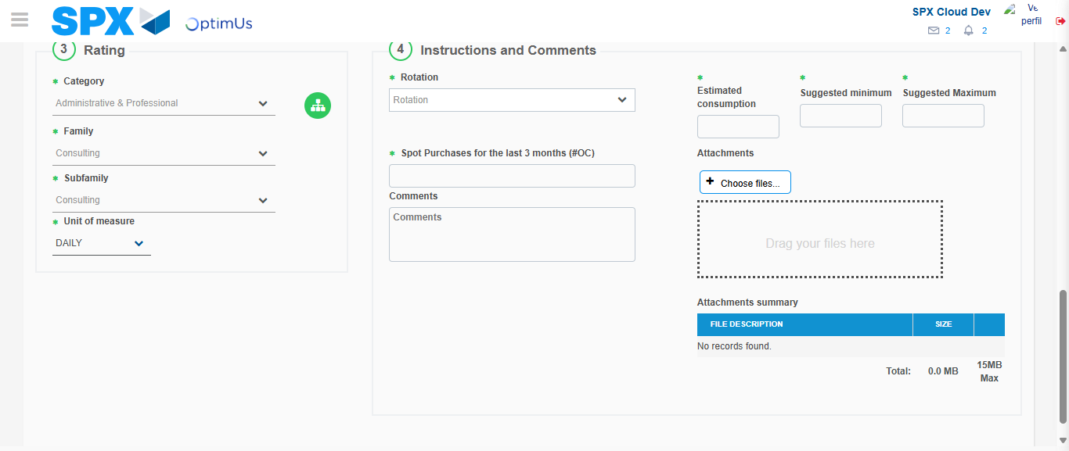Image file-name: QC_Testing-tc001_SPX_Dev5_Crear_Solicitud_Articulo_Almacen-1787933167136

Step 5 - Request New Item : Request Accepted
Image file-name: QC_Testing-tc001_SPX_Dev5_Crear_Solicitud_Articulo_Almacen-1787933119359

Image file-name: QC_Testing-tc001_SPX_Dev5_Crear_Solicitud_Articulo_Almacen-1787933119909

Image file-name: QC_Testing-tc001_SPX_Dev5_Crear_Solicitud_Articulo_Almacen-1787933148725

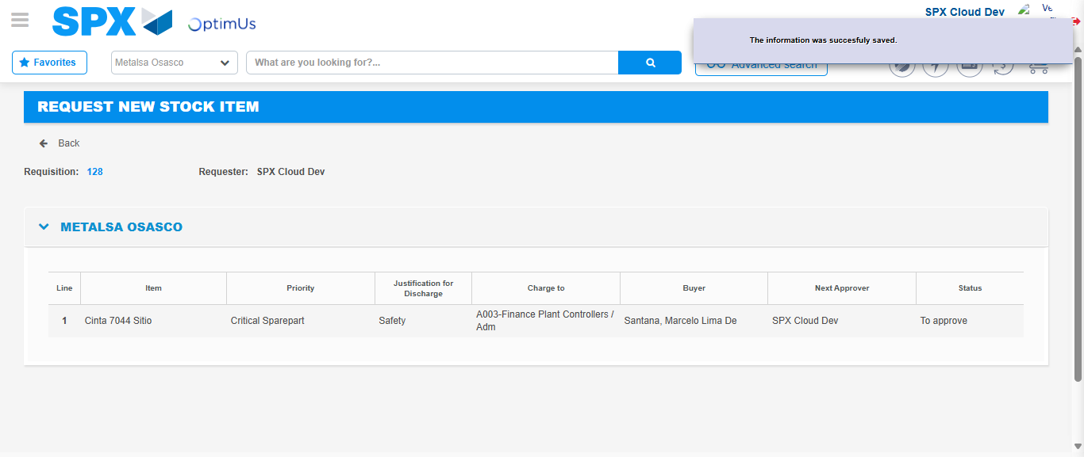Image file-name: QC_Testing-tc001_SPX_Dev5_Crear_Solicitud_Articulo_Almacen-1787933174349

Image file-name: QC_Testing-tc001_SPX_Dev5_Crear_Solicitud_Articulo_Almacen-1787933174567

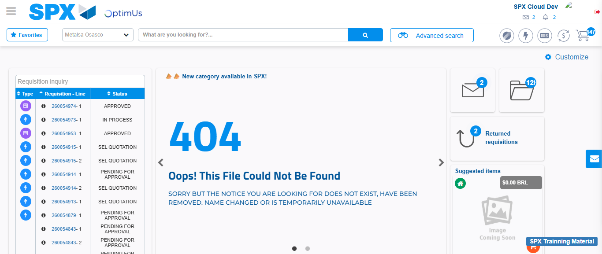Image file-name: QC_Testing-tc001_SPX_Dev5_Crear_Solicitud_Articulo_Almacen-1787933196608

Step 7 - Return to Main Page SPX : Return to Main Page SPX
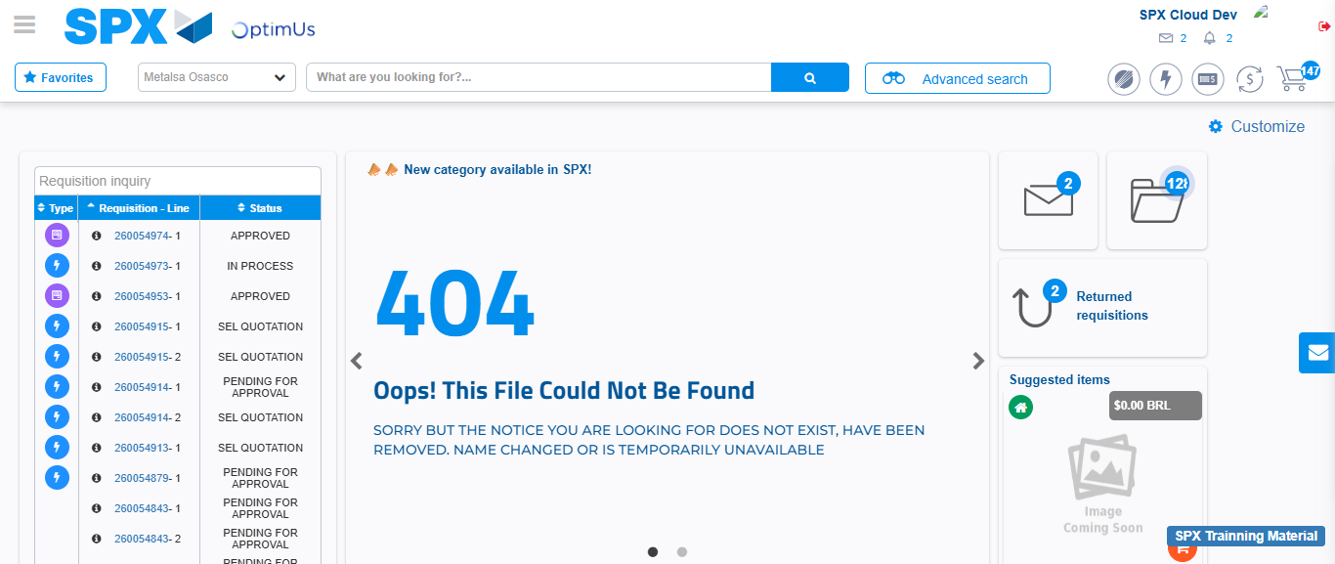Image file-name: QC_Testing-tc001_SPX_Dev5_Crear_Solicitud_Articulo_Almacen-1787933197051

